## Lecture 5 Practice - SQL

**Part I. Consider the following relations:**

## Hotel (hotelNo, hotelName, city)

## Room (roomNo, hotelNo, type, price)

## Booking (hotelNo, guestNo, dateFrom, dateTo, roomNo)

## Guest (guestNo, guestName, guestAddress)

(The underlined attributes form the primary key.)

Write SQL statements to perform the following:

1. Create the Hotel table, Guest table
2. Create the Room table with the following conditions:
   1. Room types with the following possibilities: Standard, Deluxe, Suite.
   2. Hotel numbers that are present in the Hotel table.
   3. Room prices between $50.00 and $500.00.
   4. Room numbers between 1 and 9999
3. Create the Booking table:
   1. Allowing only guests that are present in the Guest table
   2. The hotel room must be in the Room table
   3. dateFrom must precede the dateTo.

**Useful commands:**

CREATE TABLE TableName

({columnName DataType [NOT NULL] [UNIQUE]

[DEFAULT defaultOption] [CHECK (searchCondition) [,…]}

[PRIMARY KEY (listOfColumns),] [UNIQUE (listOfColumns) [,…]]

[FOREIGN KEY (listofForeignKeyColumns)

REFERENCES ParentTableName [(listofCandidateKeyColumns)],

[ON UPDATE referentialAction] [ON DELETE referentialAction] [,…]]

[CHECK (searchCondition) [,…]]);

**Data types:**

CHAR(length)

VARCHAR(maxLength)

DECIMAL(digits,precision) - the precision is the number of digits after the decimal point

DATE

**Example:**

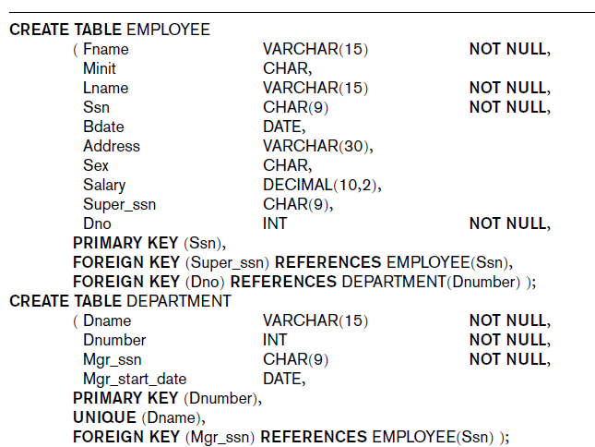

## Part II Query

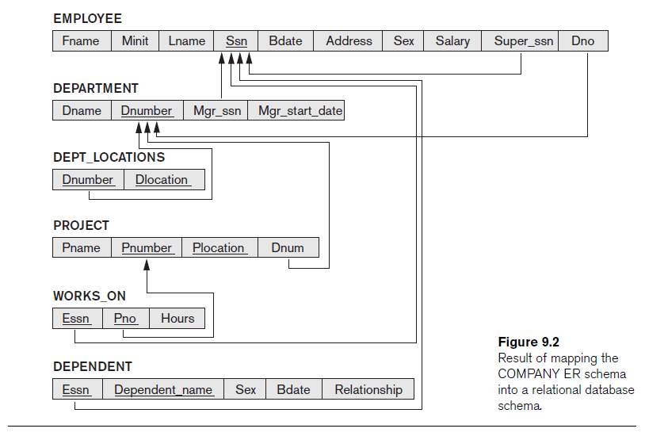

**Query syntax:**

SELECT [DISTINCT] {* | [columnExpression [AS newName]] [,…]}

FROM TableName [alias] [,…]

[WHERE condition]

[GROUP BY columnList

[HAVING condition] ]

[ORDER BY columnList]

Part II. SQL query

1. For every project located in ‘Stafford’, list the project number, the controlling department number, and the department manager’s last name, address, and birth date.

2. List first name, last name, and address of all employees working in ‘Research’ department

3. List location(s) of ‘Research’ department

4. List every employee name and his/her supervisor name

5. List all distinct employee salary

6. Retrieval all employees’ names whose address is in Houston

7. Retrieval all employees’ names who were born during the 1970s